Create a Maven Project with TestNG in Selenium

1. Install Required Tools
- Java Development Kit (JDK) (Optional)
  - Make sure JDK is installed. It is required to write and execute Java code.
  - If you haven’t installed it in your system, don’t worry IntelliJ will do the honors for you
  - In case, download from https://www.oracle.com/java/technologies/downloads/#java11-windows
- IntelliJ IDEA
  - IntelliJ IDEA is one of the most popular IDEs for Java development.
  - Download using this URL: https://www.jetbrains.com/idea/download/?section=windows

2. Create a Maven Project in IntelliJ

Step 2.1: Open IntelliJ and Create a New Maven Project
- Open IntelliJ IDEA.
- Go to File > New > Project.
- Select Maven from the list of project types.
- Location shall be your lab’s desktop.
- Uncheck the checkboxes highlighted in green box below.
- (Optional) Enter the Group ID and Artifact ID (e.g., com.example and SeleniumTestProject)
- Click Create to create the project.
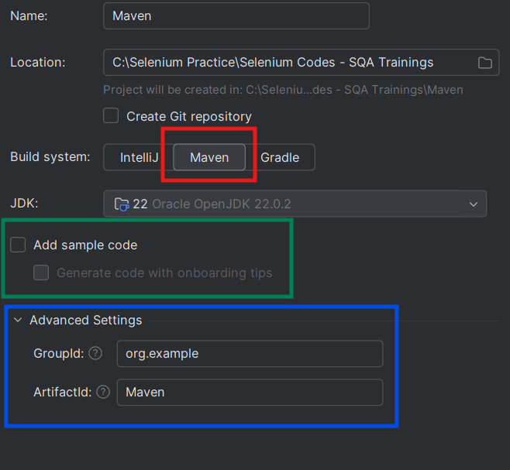

Step 2.2: Structure the Project and Add Required Files
When the project is created, it should contain:
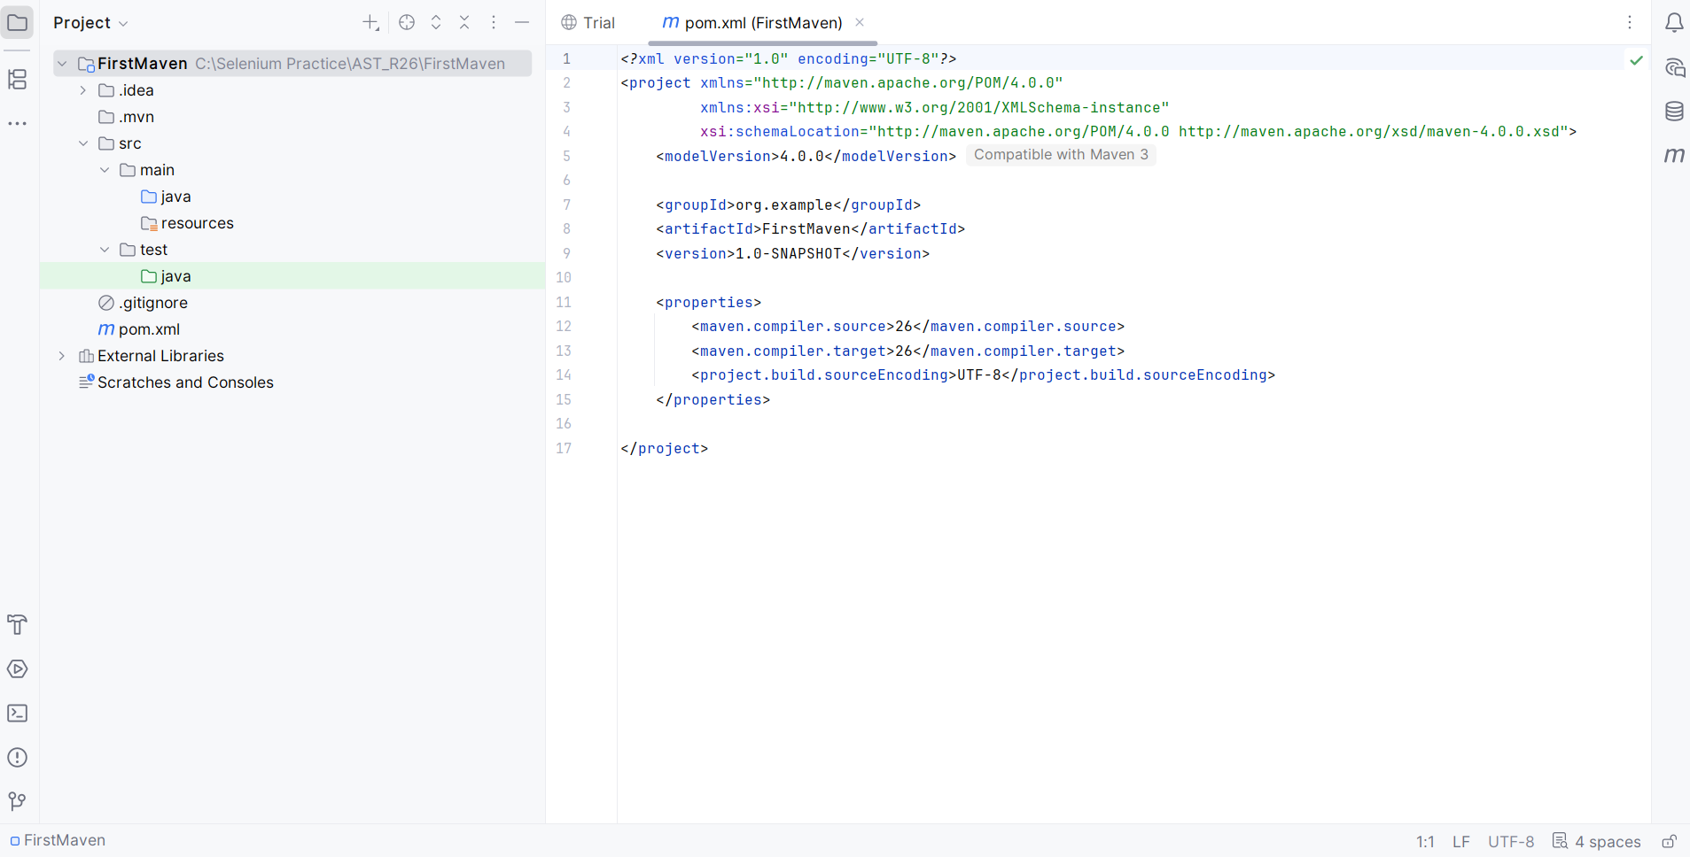
- src/main/java (for application code, which isn’t typically needed in a test automation project).
- src/test/java (where test code is stored).
- pom.xml file (for managing dependencies).

Step 2.3: Configure Dependencies in pom.xml
- Open the pom.xml file in your project root.
- Add dependencies for Selenium and TestNG.
  - Paste the code mentioned in the table below after </properties> tag:
    - These dependencies are taken from the maven repository https://mvnrepository.com/ (as we practiced during the class).
<dependencies>
<!-- Source: https://mvnrepository.com/artifact/org.seleniumhq.selenium/selenium-java -->
<dependency>
<groupId>org.seleniumhq.selenium</groupId>
<artifactId>selenium-java</artifactId>
<version>4.39.0</version>
<scope>compile</scope>
</dependency>
<!-- Source: https://mvnrepository.com/artifact/org.testng/testng -->
<dependency>
<groupId>org.testng</groupId>
<artifactId>testng</artifactId>
<version>7.8.0</version>
<scope>test</scope>
</dependency>
</dependencies>

- Click on this icon at the top right, IntelliJ should automatically download the necessary dependencies.
For Selenium, I’ve used this URL from Maven repo: https://mvnrepository.com/artifact/org.seleniumhq.selenium/selenium-java/4.39.0
For TestNG, I’ve used this URL from Maven repo: https://mvnrepository.com/artifact/org.testng/testng/7.8.0

Step 2.4: Create a Test Class
Now that the project is set up, let's write a script to:
- Open a browser.
- Maximize the browser window
- Navigate to a URL.
- Print its title.
- Minimize the browser window
- Close the browser.
- Right-click on the src/test/java folder and create a new package tests.
- Inside the tests package, create a new Java class FirstTest.
- Add this sample TestNG test case:
// Declares that this class belongs to the 'tests' package.
package tests;
// Imports the WebDriver interface for browser automation.
import org.openqa.selenium.WebDriver;
// Imports the ChromeDriver class to launch and control the Chrome browser.
import org.openqa.selenium.chrome.ChromeDriver;
// Imports the @AfterClass annotation from TestNG.
import org.testng.annotations.AfterClass;
// Imports the @BeforeClass annotation from TestNG.
import org.testng.annotations.BeforeClass;
// Imports the @Test annotation from TestNG.
import org.testng.annotations.Test;
// Declares a public class named FirstTest.
public class FirstTest {
// Declares a WebDriver reference variable.
WebDriver driver;
// Runs once before all test methods in this class.
@BeforeClass
// Defines the setup method and allows InterruptedException.
public void setup() throws InterruptedException {
// Creates a new Chrome browser instance.
driver = new ChromeDriver();
// Pauses execution for 3 seconds.
Thread.sleep(3000);
// Maximizes the browser window.
driver.manage().window().maximize();
// Pauses execution for another 3 seconds.
Thread.sleep(3000);
}
// Marks this method as a TestNG test case.
@Test
// Defines the test method and allows InterruptedException.
public void testcase() throws InterruptedException {
// Opens the specified website in the browser.
driver.get("https://mvnrepository.com/");
// Waits for 3 seconds.
Thread.sleep(3000);
// Prints the title of the current web page to the console.
System.out.println("The title of the page is: " + driver.getTitle());
// Minimizes the browser window.
driver.manage().window().minimize();
// Waits for 3 seconds.
Thread.sleep(3000);
// Maximizes the browser window again.
driver.manage().window().maximize();
// Waits for another 3 seconds.
Thread.sleep(3000);
}
// Runs once after all test methods in this class.
@AfterClass
// Defines the cleanup method.
public void teardown() {
// Closes all browser windows and ends the WebDriver session.
driver.quit();
}
}

Code Explanation
- Package Declaration: Places the FirstTest class in the tests package for better project organization.
- Import Statements: Import Selenium classes for browser automation and TestNG annotations for test execution.
- WebDriver Declaration: Declares a WebDriver object to control the Chrome browser.
- @BeforeClass – Setup Method: Runs once before the test to:
  - Launch the Chrome browser.
  - Maximize the browser window.
- @Test – Test Case Method: Executes the test by:
  - Opening the MVN Repository website.
  - Printing the page title.
  - Minimizing and maximizing the browser window.
- @AfterClass – Teardown Method: Runs after the test to:
  - Close the browser.
  - End the WebDriver session using driver.quit().

Step 2.5: Run the Test
- Right-click on the FirstTest class.
- Select Run 'FirstClass' to execute the test.
- Observe the console for the output, and check if the test runs successfully.
Final structure of your project should look like this.
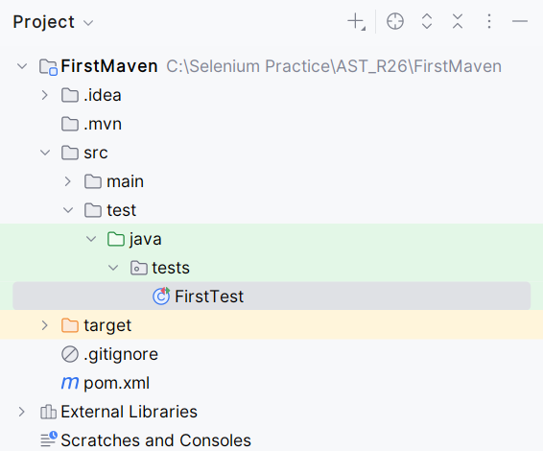

3. Best Practices
- Always close the browser session: Use driver.quit() to close the browser and free up system resources.

4. Exercise for Students
- Task 1: Set up your Maven Selenium project in IntelliJ, open Google.com, and print the page title.
- Task 2: Change the website URL to another favourite website, open the browser, print the page title, and close the browser.

5. Conclusion
- Recap: You’ve learned how to set up a basic Selenium project in Java using IntelliJ, how to open a browser, navigate to a URL, and close the browser.
- Next Steps: In the next lecture, we’ll learn about interacting with web elements like buttons, text fields, and checkboxes using Selenium.

6. HomeTask
- Explore navigating different browser drivers like Firefox and Edge to your project using Selenium.

